|  |  |  |
| --- | --- | --- |
| **[1]Project Members:** | **Number:** | 171805072 |
| **Name:** | Fatih SAĞLAM |
| **Number:** | 181805030 |
| **Name:** | Fatih BIÇKI |
| **Number:** | 171805074 |
| **Name:** | Emrah AKÇİN |
| **Number:** | 191805107 |
| **Name:** | Esat ARSLAN |
| **Project info:** | **Project Name: Book of Small Town Place**  **Team Name:FEEF SOFTWARE**  **Spokesman:Fatih SAĞLAM**  **Due date: 24/11/2020** | |
| **Team agreement decisions :** | **Methods of communication**: phone and email  **Communication response time**: 15 -20 minutes  **Meeting attendance**: mandotory by all grup members twice a week **Running meetings**: whenever everyone is avaible, on discord app, Fatih takes notes  **Meeting preparation**: a stabil internet connection and documents  **Version control:** not necessary  **Division of work**:it will be decided together as a group  **Submitting assignments**:Fatih will sumbit after its been validated by every group member contingency  **Planning**:if a team member dropts out rest of the team will carry on and drop out's tasks will be shared equally to each team member | |
| **Github Adress:** | Fatih SAĞLAM:<https://github.com/Fatih-61>  Fatih BIÇKI:<https://github.com/fatihbicki>  Emrah AKÇİN:<https://github.com/CompEng-coder>  Esat ARSLAN:<https://github.com/esatarslan66> | |

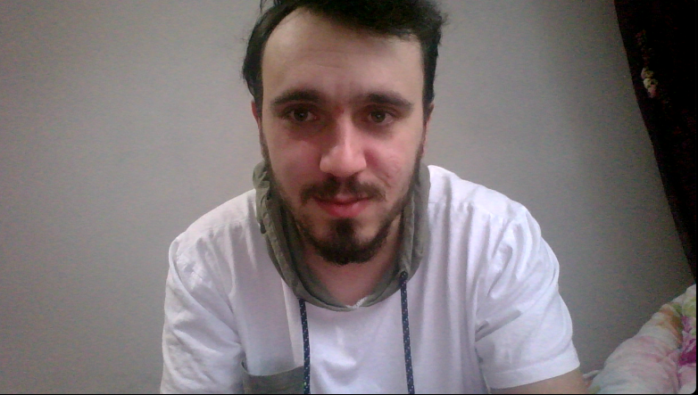

FATİH SAĞLAM

He was born on May 26, 1998 in Trabzon. He completed all his education until high school in Trabzon. In 2017, he won the Computer Engineering Department of Adnan Menderes University. He still continues his university education.Since his financial situation is not very good and he does not want to be a burden to his family, he pays his education expenses by working in holiday regions in the summer.

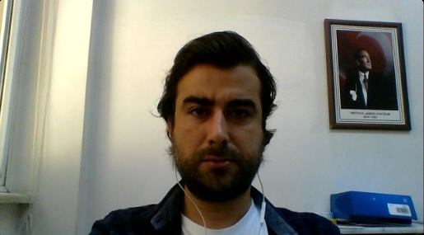

**Emrah AKÇİN**

He was born on October 8, 1988 in Izmir and lived there until the age of 11. Then he moved to Aydın. He completed his high school education in Aydın Anatolian Technical High School. Afterwards, he graduated from Hacettepe University Computer Technologies and Programming Department in 2009. He went on military service in 2011 and passed the civil service exam while in the military. In 2013, he was appointed to the city where he lived and took office. He passed the DGS exam in 2017 and started Andan Menderes University and is still a student here.

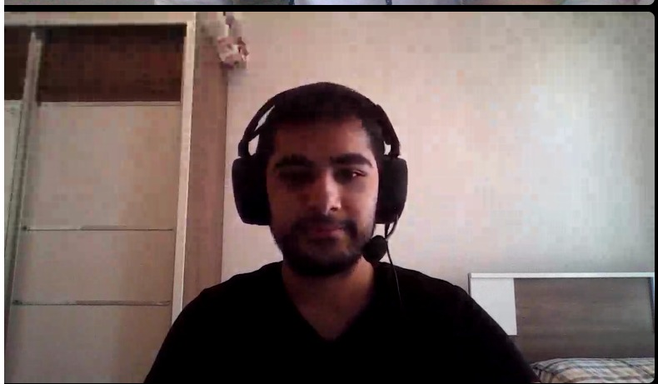

Fatih Bıçkı born in 3 March 2000. He grew up in Antalya as a smallest kid in family with one brother and one sister.

After he graduated from middle school he started to his high school education at Göynük Fen Lisesi.

He attended to various tournements of table tennis and chess while he was in high school.

He successfully completed his high school education in 2018.

He decided to continue his education in computer engineering at Adnan Menderes University because of passion he have from childhood to computers and how they work.

For his recent 3 years in university as student, he kept improve his skills with courses from internet and good-know university's online courses.

He learned the importance of ethically working as a engineer from his teachers.

His goal for future is become a world wide engineer.

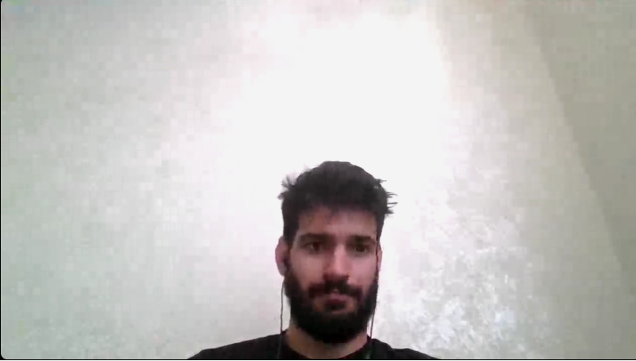

Esat arslan was born in hatay,samandağı at 1997. He completed his primary and middle school at same town he born. Then he continued to his high school at Jan ve Suphi anadolu lisesi which was a old French school. After high school, he won the physiotherapy department at Şişli Vocational School. After 2 years of study he decided this is not the job he wanted for himself to live on his life so drop out from the school and studied for a chance of computer science engineer. And he won computer science engineer department ad Adnan Menderes University. Currently he still studies. At the same time he was one of the finding members of Ege Universiy's Animal rights society. Also he is a licensed football and chess player.

1.